
Westcountry Schools Trust (WeST)

Suspension and Exclusion Policy

Mission Statement
Westcountry Schools Trust (WeST) holds a deep-seated belief in education and lifelong learning. Effective collaboration, mutual support and professional challenge will underpin our quest to ensure that all of the students and adults we serve are given every opportunity to fulfil their potential and succeed in life.

Person(s) responsible for updating the policy: | Members of WeST Core Team
Date Approved: | July 2024 (for implementation from 1/9/24)
Date of next review: | July 2026
Status: | Guidance

WeST Core Values
WeST holds four core values which underpin the engagement, motivation and retention of employees, no matter what their role in the organisation.

- Collaboration
Creating a shared vision and working effectively across boundaries in an equitable and inclusive way to skilfully influence and engage others. Building and securing value from relationships, developing self and others to achieve positive outcomes.
- Aspiration
Having high expectations, modelling the delivery of high-quality outcomes. Showing passion, persistence and resilience in seeking creative solutions to strive for continuous improvement and excellence.
- Integrity
Acting always with the interests of children and young people at our heart, and with a consistent and uncompromising adherence to strong moral and ethical principles. Communicating with transparency and respect, creating a working environment based on trust and honesty.
- Compassion
Recognising need in others and acting with positive intention to promote well-being and improve outcomes.

Providing Accessible Formats
If you are unable to use this document and require it in a different format, please contact the Director of Inclusion.

Relevant Legislation and Guidance
This policy should be read alongside the following documents:
- The school behaviour policy
- The school SEND policy
- Latest version of Department for Education (DfE) guidance, “Suspension and permanent exclusion from maintained schools, academies and pupil referral units in England, including pupil movement” (currently Sept 2023)
- Latest version of DfE guidance, “Behaviour in Schools” (currently Feb 2024)
- Latest version of DfE guidance, “A guide for parents on school behaviour and exclusion” (currently DfE May 2023)
- Latest version of SEND Code of Practice (currently Jan 2015)

Note on terminology
The following terms are used throughout this policy:
- Parent(s) refers to parents or carers, including the Local Authority for children who are in care.
- Suspension refers to what were previously known as fixed-term or fixed-period exclusions.
- Exclusion refers to permanent exclusion

The power to suspend or exclude
Only the Headteacher has the power to suspend or exclude a child. Other members of staff such as Heads of Year (Secondary) or Class Teachers (Primary) cannot suspend, though they may /provide information to support the Headteacher’s decision.

WeST recognises that children with special educational needs, or other vulnerabilities, may be disproportionately suspended for demonstrating behaviours that are a manifestation of an unmet need. Careful consideration should be given to alternative means of support for pupils with SEND who are facing accruing suspensions.

Where Headteachers are unsure about a suspension they should seek advice from relevant colleagues in the WeST School Improvement team. All primary suspensions and must be reported using this MS Form. Any possible permanent exclusion must be discussed with the Deputy Chief Executive Officer (DCEO) and recorded on this MS Form.

Reasons for suspension or permanent exclusion
All suspensions and permanent exclusions must be for disciplinary reasons only. Individual school behaviour policies set out what the school's expectations and rules are.

Standard of proof
The Headteacher’s decision to suspend or permanently exclude must be taken on the ‘balance of probabilities.’ This means that it is more likely than not that the pupil did that which they are alleged to have done. This is not the same as ‘beyond reasonable doubt’, the standard required in a criminal case.

When suspension is not allowed
It is unlawful to suspend or to lengthen a suspension for a non-disciplinary reason. Some examples are below:
- If the suspension is specifically about a child’s special educational needs (however, this does not mean a child with SEND cannot be suspended, if appropriate).
- If a child is not doing well in school or is not as able as other children. A child cannot be suspended or excluded because they are not likely to get good results in tests or exams.
- Due to something a parent has done. That might be something like making a complaint or not going to a meeting at school.
- Not allowing a child back into school after a suspension unless they meet particular conditions. Once the suspension is ended a child must be allowed to go back. For example, the Headteacher cannot extend the suspension because a child will not admit they are guilty or refuses to make an apology.

Off-rolling
WeST and its constituent school recognise that off-rolling is unlawful. Ofsted defines off-rolling as, "the practice of removing a pupil from the school roll without a formal, permanent exclusion or by encouraging a parent to remove their child from the school roll, when the removal is primarily in the interests of the school rather than in the best interests of the pupil."

WeST is committed to following all statutory procedures to ensure that every child in a WeST school receives an education in a safe and caring environment.

Behaviour outside school
Pupils can be suspended or permanently excluded for behaviour outside school in line with the school’s behaviour policy. Commonly this will include behaviour on school trips, behaviour when in uniform, on the way to and from school (including school buses and public transport), and behaviour which may bring the school into disrepute.
Pupil voice
Headteachers should take reasonable steps to ensure that any excluded pupil is enabled and encouraged to participate at all stages of the suspension or permanent exclusion process. They should take the pupil’s views into account, considering these in light of their age and understanding, before deciding to suspend or permanently exclude, unless it would not be appropriate to do so. WeST recognises that there may be occasions when a decision has to be made before a child is able to give a full and reasoned account of their actions, e.g. where a pupil has become dysregulated. Where such a decision is made parents can find out their child’s version of what happened and communicate this to school themselves.

The Headteacher’s duty to inform parents about a suspension
If a pupil is given a suspension, parents must be notified in writing without delay in line with the DfE guidance. WeST schools will use the templates provided by the relevant local authority.

Parents should also be informed of their right to make representation about a suspension or permanent exclusion to those in governance. In WeST schools the Trustees have delegated the oversight of suspensions and permanent exclusions to members of the Hub Advisory Boards (HABs). Trustees will, through appropriate members of the School Improvement Team, ensure that HAB members are sufficiently trained to fulfil this role.

Keeping a child at home
If the pupil is of compulsory school age, parents must also be told about their responsibilities to keep them at home during the first five days of the suspension or permanent exclusion. This should be covered in the exclusion letter.

The first five days
Even though the pupil has been suspended they still should be receiving education. The school will take reasonable steps to set work for the first five days of any suspension or permanent exclusion.

During these five days, parents are responsible for their child’s whereabouts. Parents must make sure they are not in a public place without reasonable justification during school hours. This duty is like that on school attendance and parents could be fined if they breach it.

Day six and beyond
If a child has been given a longer suspension of more than five days the school, in conjunction with the local authority, has a duty to provide suitable full-time alternative education from day six. That is most likely to take place at an appropriate alternative provision.

If a pupil with special educational needs has an Education and Health Care Plan (EHCP) the alternative provision must be able to meet the pupil’s needs as set out in the EHCP. The placement must be identified in consultation with parents.

For looked after children, it is recommended that alternative educational provision start from the first day of a suspension lasting more than 5 days.

Re-integration meetings
There should always be a re-integration meeting when a pupil returns from a suspension. Every effort should be made to ensure that the parent(s) are able to attend this meeting. At this meeting, it is important to look at how home and school can work together to avoid problems in the future. Appendix 4 contains guidance on the format of such a meeting. A written record of the meeting should be kept. Where the parent(s) are unable to attend the meeting, they should be informed in writing of the outcome of the meeting.

Consideration should be given prior to the re-integration meeting whether an individual risk assessment is required to ensure the ongoing safety of the pupil and other members of the school community. Where this is deemed necessary the risk assessment/safety plan, including mitigating actions, should be agreed at the re-integration meeting.

Where a pupil has been harmed by the action of another careful consideration should be given to any support that they may require to feel safe on the return of the pupil who has caused the harm. Schools should record this support in writing, e.g. via an individual safety plan stored on CPOMS.

Permanent exclusion
The decision to exclude a pupil permanently is a very serious one. A decision to exclude a pupil permanently should only be taken:
- in response to a serious breach or persistent breaches of the school’s behaviour policy; and
- where allowing the pupil to remain in school would seriously harm the education or welfare of the pupil or others in the school.

Pupils may be permanently excluded for the following reasons:
- Physical assault against a pupil
- Physical assault against an adult
- Verbal abuse or threatening behaviour against a pupil
- Verbal abuse or threatening behaviour against an adult
- Use, or threat of use, of an offensive weapon or prohibited item that has been prohibited by a school’s behaviour policy
- Bullying
- Racist abuse
- Abuse against sexual orientation or gender reassignment
- Abuse relating to disability

This list is not exhaustive but indicates the severity of such incidents and the fact that such behaviour seriously affects the discipline, safety and well-being of the school.

A pupil can be permanently excluded for committing a single, serious one-off offence, even if they have no previous history of breaching the school’s behaviour policy. Each decision around a permanent exclusion needs to be made with careful consideration of the circumstances involved, including any additional needs of the pupil. Headteachers should seek support from the Deputy Chief Executive Officer when considering a permanent exclusion.

If a child is recommended for permanent exclusion a Governance Disciplinary Committee (GDC) will be held within 15 school days to hear the case and decide whether to uphold the Headteacher’s decision or to re-instate the pupil. The panel will most likely consist of three Hub Advisory Board members but could also include Trustees if HAB members are not available. The child and their parents will be invited to attend the hearing to present their case, along with the Headteacher and key personnel. Local authority inclusion officers and an appropriate member of the WeST School Improvement Team may also be invited. Parents will be written to with clear details about the process and their right to appeal the decision, should they disagree with the GDC’s decision.

Taking account of individual pupil needs
WeST recognises its legal duties under the Equality Act 2010, and those in respect of safeguarding and supporting pupils with special educational needs. As a trust, we are keen to ensure that we do not discriminate through the application of our school behaviour policies, against pupils whose apparent inappropriate behaviour may be a function of SEND needs or other protected characteristics.

Therefore, when intervening with apparent inappropriate behaviour all staff must accept that there will be circumstances in which some pupils may be treated differently from others and are expected to take account of those individual pupil needs when applying consequences, including suspension or permanent exclusion. Staff should make use of the support available from the school SENDCO and the WeST Lead Practitioner for Inclusion as appropriate.

Appendix 1 – Permanent Exclusion Decision-making Flow Chart

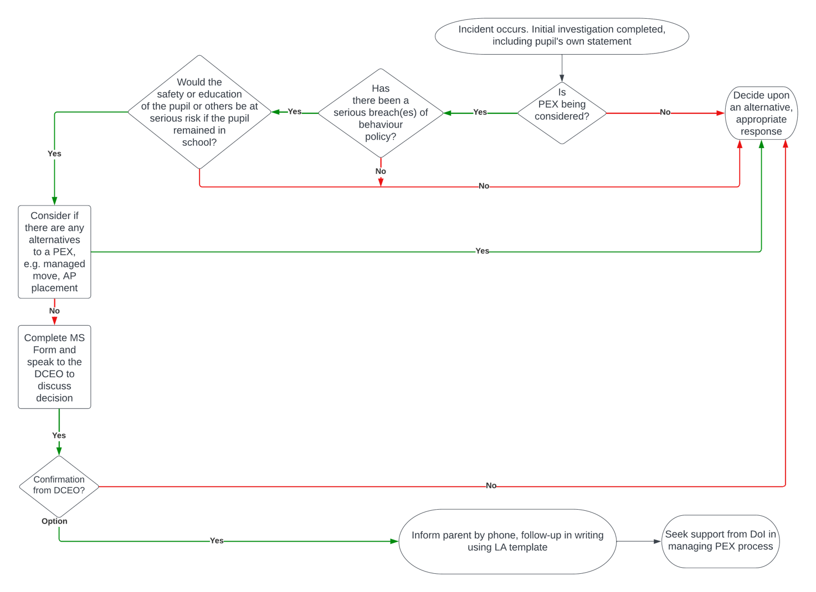

Appendix 2 – Primary Suspension and Exclusion Guide
NB - Staff should complete this form directly online using the MS Form. A copy of the form can be saved by the user and then printed as a PDF to be attached to the pupil’s school record.

Pupil Name: |  |  |  |  |  |  |  |  | Attendance (YTD):
Year: |  |  |  |  |  |  |  |  | LAC / PLAC / CP / CP / EH?
Class Teacher: |  |  |  |  |  |  |  |  | Disadvantaged?
SEND? |  |  |  |  |  |  |  |  | EAL?
Overview of SEND Needs:
Phonics or Reading Score & interventions:
Previous Behaviour:  (last 12 months) | Written Summary: |  |  |  |  |  |  |  |  |  |  |  | No. of suspensions: |  |  | No. of days suspended:
Type of Incident: | OW - Use or threat of use of an offensive weapon or prohibited item |  |  |  |  |  |  |  |  |  | LG - Abuse against sexual orientation and gender identity
 | DS - Abuse relating to disability |  |  |  |  |  |  |  |  |  | MT - Inappropriate use of social media or online technology
 | VA - Verbal abuse / threatening behaviour against an adult |  |  |  |  |  |  |  |  |  | BU - Bullying  (consider ‘STOP’ - Several Times On Purpose)
 | RA - Racist abuse |  |  |  |  |  |  |  |  |  | SM - Sexual misconduct
 | PH - Wilful and repeated transgression or progressive measures in place for public health and safety |  |  |  |  |  |  |  |  |  | PP - Physical assault against pupil
 | PA – Physical assault against adult |  |  |  |  |  |  |  |  |  | VP – verbal abuse / threatening behaviour against pupil
 | DA – Drug or alcohol related |  |  |  |  |  |  |  |  |  | DM – Damage to property
 | TH – Theft |  |  |  |  |  |  |  |  |  | DB – Persistent or general disruptive behaviour
Summary of Incident:

 | Written statement from pupil? |  |  |  |  |  | Written statement from staff? |  |  |  | Written statements from pupil witnesses?
SEND considerations: | If the pupil has an identified SEND need, or one is suspected, please describe what reasonable adjustments and provision are in place to support the people and how these were followed in the lead up to the incident.
Decision: | Suspension |  |  |  |  |  | No. of Days |  |  |  | Permanent Exclusion
Rationale for decision:
Checklist against WeST exclusion policy and DfE Guidance: |  |  |  |  |  |  |  |  |  | Y/N/NA |  | Date/Time and method of agreement
Is this a permanent exclusion?
If so, has the WeST DCEO agreed with the decision and have you completed the MS Form?
Will this suspension take the number of school days missed to more than 15 in a term? (If so, a Governance Disciplinary Committee must be arranged)
Re-integration Meeting |  | Date: |  |  |  | Time: |  |  |  | Location:
 |  | Persons to be invited:
Appendix 3 – Secondary External Reflection, Suspension and Permanent Exclusion Guide

Pupil Name: |  |  |  |  |  |  |  |  |  |  | Attendance (YTD):
Year: |  |  |  |  |  |  |  |  |  |  | LAC / PLAC / CP / CP / EH?
Head of Year: |  |  |  |  |  |  |  |  |  |  | Disadvantaged?
SEND? |  |  |  |  |  |  |  |  |  |  | EAL?
Overview of SEND Needs:
NGRT Score and interventions:
Previous Behaviour:  (last 12 months) |  | No. of internal reflections: |  |  |  |  |  |  | No. of external reflections: |  |  |  | No. of suspensions: |  |  |  |  |  | No. of days suspended:
Type of Incident: |  | OW - Use or threat of use of an offensive weapon or prohibited item |  |  |  |  |  |  |  |  |  |  | LG - Abuse against sexual orientation and gender identity
 |  | DS - Abuse relating to disability |  |  |  |  |  |  |  |  |  |  | MT - Inappropriate use of social media or online technology
 |  | VA - Verbal abuse / threatening behaviour against an adult |  |  |  |  |  |  |  |  |  |  | BU - Bullying  (consider ‘STOP’ - Several Times On Purpose)
 |  | RA - Racist abuse |  |  |  |  |  |  |  |  |  |  | SM - Sexual misconduct
 |  | PH - Wilful and repeated transgression or progressive measures in place for public health and safety |  |  |  |  |  |  |  |  |  |  | PP - Physical assault against pupil
 |  | PA – Physical assault against adult |  |  |  |  |  |  |  |  |  |  | VP – verbal abuse / threatening behaviour against pupil
 |  | DA – Drug or alcohol related |  |  |  |  |  |  |  |  |  |  | DM – Damage to property
 |  | TH – Theft |  |  |  |  |  |  |  |  |  |  | DB – Persistent or general disruptive behaviour
Summary of Incident:

 |  | Written statement from pupil? |  |  |  |  |  | Written statement from staff? |  |  |  |  | Written statements from pupil witnesses?
SEND considerations: | If the pupil has an identified SEND need, or one is suspected, please describe what reasonable adjustments and provision are in place to support the people and how these were followed in the lead up to the incident.
Decision: |  | External Reflection: |  |  |  |  |  | Suspension: |  |  |  |  |  | No. of Days: |  |  | Permanent Exc:
Rationale for decision:
Checklist against WeST exclusion policy: |  |  |  |  |  |  |  |  |  |  |  | Y/N/NA |  |  | Date/Time and method of agreement:
Is this a permanent exclusion?
If so, has the WeST DCEO agreed with the decision and have you completed the MS Form?
Will this suspension take the number of school days missed to more than 15 in a term? (If so, a Governance Disciplinary Committee must be arranged)
Re-integration Meeting |  |  | Date: |  |  | Time: |  |  |  |  |  | Location:
 |  |  | Persons to be invited:

Appendix 4 – Exemplar WeST Re-integration Meeting Guide

Overall Aim:
Provide clarity of expectations and agree on the actions (positive) that need to be taken and the positive results we can expect.

Before the meeting
- Early parent and pupil notification /agreement
- Notify in advance the SLT/ HoY/ behaviour team required to attend
- Prepare the paperwork for referral in the meeting
- Re-integration proforma to record the meeting
- Copy of the letter sent to parents highlighting reason for exclusion
- Home/ college agreement – (which aspects were broken and needs revisiting)
- Review of ABC data – Attendance / Behaviour / Care (SEND/ PP/ LAC etc.)
- Decided on the key focus /outcome required

On the day of the meeting
- At the start of the day - confirmation phone call to parents

3 R’s meeting:
Re-connect (Understand before being understood)
- On arrival meet and greet using a SOFTEN approach
(Smile, Open Body Language, Forward lean, Touch – e.g. shake hands, eye contact and Nodding)
- Transpose – see the situation from their eyes
- Be open but remain assertive - you drive the meeting and take conscious control of the entire process
- Demonstrate clarity of purpose throughout the meeting
- Ensure a 80/20 pupil to teacher talk when going over the situation
- Make notes using the proforma and seek clarification whenever possible.

What happened? (Gaining clarity about the consequence, distinguishing between fact and opinion)
- Tell me how you see this situation now you have had time to reflect?
- What were you thinking at the time?
- What were you feeling at the time?
- Who do you feel was harmed and why?
- Why do you think that happened?

Repair (‘Finding the middle ground’)
- What behaviours do both parties agree the pupil needs to change moving forward?
- What behaviours does the pupil feel need show us next time?
- Were there any learning points from completing suspension work?

Restore (‘Engage in mutual problem solving’)
- Now agree on how the pupil plans to improve their behaviour
- Together agree on an achievable goal and the steps that need to be taken by the pupil/ the parents and the school to achieve this behavioural goal.
- Create clear expectation/s to live up to (how will it look, hear, feel?)
- How committed are you to making this goal happen? (Scale 1-10. For anything lower than 8 ask follow up questions)
- What help would the pupil need to make this a sustainable change?
- What could the parents do to help?

Record of Re-integration Meeting
Date
Pupil:
Present:
Stages | Notes
Introductions and stated aims of the meeting | - To reflect on the impact of the incident on everybody involved  - To understand why college has sanctioned in this way  - To ensure this type of incident does not happen again agree on actions to support this
Re-connect
‘What happened?’
Distinguish between fact and opinion

Repair
‘Finding the middle ground’
Review work completed during external reflection or suspension

Restore
Pupil’s action points
What can be done to ensure this incident is not repeated?

Parent’s action points
What can be done at home to help support the conduct in school?

School action points
What support can the school take to ensure the incident will not happen again?

Signed by
Pupil:
Parent(s):
Staff:

Version Date | Changes
January 2022 | Policy re-written:  - to reflect changes to WeST governance model (Hub Advisory Boards)  - Guide Headteachers about levels of consequence to consider for each DfE categorisation of suspension and exclusion(Appendix 7)
September 2023 | References and links changed to DfE Exclusion Guidance (Sept 2023)  Reference made to DfE Guide for Parents on school behaviour and exclusion
September 2024 | Name changed to Suspension and Exclusion Policy.  Removal of flow diagrams for primary and secondary suspensions.  Addition of MS Forms for school reporting to trust.  Removal of exemplars of behaviours under each DfE category (previously Appendix 7)

The definition of a parent can be found in the Education Act 1996, and this applies to the legislation to which this policy relates. In addition to the child's birth parents, references to parents in this policy include any person who has parental responsibility (which includes the local authority where it has a care order in respect of the child) and any person (for example, a foster carer) who has care of the child. To reflect this, this policy uses ‘parent’ to refer to both parents and carers.
https://forms.office.com/e/7f2qK2ERXF
https://forms.office.com/e/J7v7VYTiWH
DfE Exclusion Guidance, page 9 and para 4
DfE Exclusion Guidance, para 62-75
Full details of the law regarding the length for which a pupil can be suspended are set out in the DfE Exclusion Guidance
DfE Exclusions guidance para 11
DfE Exclusions guidance para 15
https://forms.office.com/e/7f2qK2ERXF
https://forms.office.com/e/J7v7VYTiWH
https://forms.office.com/e/J7v7VYTiWH

